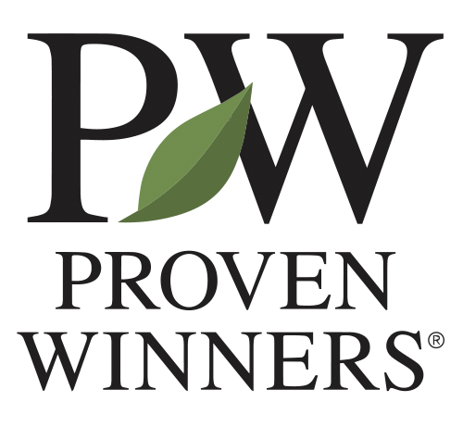
Greenhouse Growing Rotational Internship
Proven Winners, Inc.
Department | Growing
Reports To | Section Grower Team Leader, Training and Development Grower Manager, Senior Manager of Growing Personnel
Classification | Full Time, Year-Round, Exempt
Location | Carleton, Michigan
Schedule / Travel | Sunday- Thursday or Tuesday- Saturday  One weekend day is required for Section Growers  Schedule is subject to change with department shifts
JOB SUMMARY
The Greenhouse Growing Rotational Internship is heavily based on the Section Grower position at Proven Winners Carleton.

This internship will primarily focus on gaining high levels of knowledge in:
- Greenhouse Growing
  - Season Dependent
    - Stock and Mother Plants
    - Young Plants
    - Finished Crops
    - Color Choice Shrubs
- Plant Health Identification
- Multiple Irrigation Techniques
- Greenhouse Equipment
- Pesticide Applications and Growth Regulator Applications

This internship will also have the opportunity to gain knowledge in:
- Young Plant Production
  - Propagation of Vegetative Tip Cuttings
- Seed Sowing
- Shipping of Young and Finished Plants
- Finished Plant Production
- Integrated Pest Management System including:
  - Pest Identification
  - Beneficial Insects

- Tissue and Soil Sampling
- Test, Read and Adjust Soil for pH and EC
- Virus Testing
- Greenhouse Environmental Control Systems
- Inventory Management
- Product Line Management
- Four Star Greenhouses Display Garden

*All aspects of the internship are season and length of internship, dependent*
EDUCATION AND EXPERIENCE REQUIREMENTS
- Submit an online application
- Brief essay describing background, interest in field and career goals

ADDITIONAL DETAILS:
- Full Time Paid Position
- Program with flexible start and end dates
- Fully Furnished House Provided- walking distance from the Greenhouse
- Opportunity to attend “Cultivate” the largest all-industry trade show and conference in the horticulture industry
CORE VALUES:
- Collaborating as One Team, One Proven Winners: Our future success is rooted in how well we work together—as one team, who is accountable to each other. Open, transparent, and direct communication remain central to our culture. We value the diverse strengths and perspectives each person brings and are committed to fostering a collaborative, inclusive, and respectful environment where everyone feels safe to challenge and learn from each other.
- Embracing Continuous Improvement: Proven Winners was built on the belief that we could always offer something better. This mindset continues to guide us—whether improving our products, our capabilities, or how we work together. Embracing change strengthens our future and helps us continue leading the industry.
- Pursuing Excellence: From superior plant genetics to building the most trusted brand in horticulture, excellence has always defined Proven Winners. We hold ourselves to high standards across product development, customer service, operations, and internal processes. By striving for excellence in everything we do, we continue to deliver exceptional value to our customers, partners, and one another.
- Doing the Right Thing: Our brand is all about trust. We make ethical, transparent, and well-intentioned decisions, even when the outcome is difficult. We honor our commitments and rely on one another to act with integrity. Together, we uphold this value by caring for one another and the communities that we serve.
- Prioritizing Safety: We prioritize the safety of our employees above all else. Our approach is proactive and prevention-focused, ensuring we maintain safe facilities, provide proper training, and empower every employee to prioritize safety in their daily work

PHYSICAL ASPECTS
- Bulk of the job is spent standing or walking, bending to the ground and reaching overhead, pulling carts on 4-wheel castors weighing over 200 lbs.
- Lifting a minimum of 25 lbs.
- Must pass respirator evaluation and “fit” test and maintain the ability to have a safe proper fit of a respirator on an ongoing basis.
- Employee will be exposed to the sun and/or high intensity lights.
- Employee will work in a wet environment where clothes and footwear can become saturated.
- Employee may be exposed to temperatures that can be at or 10-20 degrees above outside temperature. Employee may be exposed to temperatures that can be at or slightly above freezing for long periods of time.
- Rolling, unrolling, and using irrigation hoses & high-pressure hoses.
WORK ENVIRONMENT
Greenhouse, warehouse and outdoor work settings. Peak season periods may require increased hours, responsiveness and flexibility. Reasonable accommodation may be made for individuals with disabilities to perform the essential functions.
NOTE
This job description does not exclude responsibilities not specifically stated, but that are apparent, related, or may develop in the normal course of duty.

