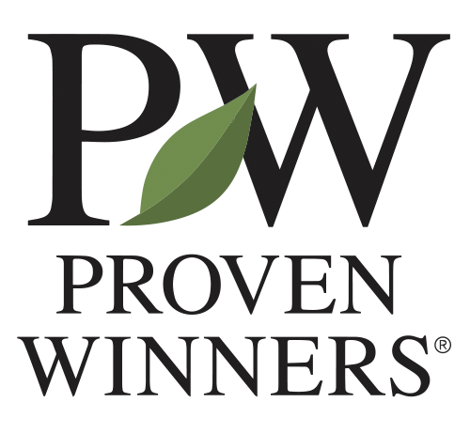
Inside Sales Representative
Proven Winners, Inc.
Department | Sales
Reports To | Director of Sales
Classification | Full Time, Year-Round, Non-Exempt / Hourly
Location | Remote; Reporting to Carleton, Michigan
Schedule / Travel | Monday – Friday, core business hours. Limited travel for trade shows, customer events, and team meetings; travel typically less than 10%.
JOB SUMMARY
Generate and grow sales for Proven Winners products and programs by managing an assigned portfolio of grower, retailer, and landscaper accounts through phone, email, video, and digital engagement. Serve as a proactive, solutions-oriented sales partner for customers — handling inbound opportunities, driving outbound outreach, managing the order process, and building the kind of responsive, knowledgeable relationships that make Proven Winners the preferred brand in the marketplace. Maintain disciplined use of Salesforce to manage account activity, track pipeline, and support accurate forecasting and performance reporting.
ESSENTIAL FUNCTIONS
- Manage an assigned portfolio of inside accounts across grower, retail, or landscaper segments; develop and execute account plans to retain customers, grow order volume, and expand program participation.
- Conduct proactive outreach to existing and prospective customers via phone, email, and video to present products, programs, and seasonal promotions, and secure orders.
- Respond promptly to inbound customer inquiries, product questions, order requests, and program interest; convert inquiries into sales opportunities at a high rate.
- Utilize Salesforce to manage all account activity, document customer interactions, track opportunities, maintain pipeline visibility, prepare forecasts, and support performance reporting.
- Develop new business within assigned accounts and through prospecting, referral follow-up, and cold outreach to target customers identified in collaboration with the sales team.

- Collaborate with outside sales representatives, retail solutions managers, and grower account managers to ensure seamless coverage and coordinated account strategy on shared accounts.
- Stay current on Proven Winners product lines, genetics introductions, program updates, promotional calendars, and competitive offerings; communicate this knowledge to customers with confidence.
- Support order accuracy and follow-through by coordinating with customer service, operations, and fulfillment teams on order status, substitutions, and delivery communications.
- Introduce, promote, and support Proven Winners programs including branded signage, point-of-sale materials, Certified Garden Center training, and digital tools relevant to inside accounts.
- Participate in weekly sales team meetings, sharing customer feedback, market intelligence, and recommendations for program or process improvements.
REQUIRED KNOWLEDGE, SKILLS, AND ABILITIES
- Strong inside sales, account management, or customer relationship skills with a demonstrated ability to close business and grow accounts over the phone and digitally.
- Excellent verbal and written communication skills; professional, confident, and persuasive in remote selling environments.
- Demonstrated ability to use Salesforce consistently and effectively for account management, opportunity tracking, forecasting, and follow-through.
- Strong organizational skills and follow-up discipline; ability to manage a high-volume account portfolio while maintaining accuracy and responsiveness.
- Collaborative mindset and the ability to work effectively with outside sales, customer service, marketing, and operations teams.
- Self-motivated and accountable; comfortable managing independent workload with limited supervision while consistently hitting activity and revenue targets.
- Working knowledge of horticulture, garden center products, or branded consumer programs preferred but not required.
CORE VALUES:
- Collaborating as One Team, One Proven Winners: Our future success is rooted in how well we work together—as one team, who is accountable to each other. Open, transparent, and direct communication remain central to our culture. We value the diverse strengths and perspectives each person brings and are committed to fostering a collaborative, inclusive, and respectful environment where everyone feels safe to challenge and learn from each other.
- Embracing Continuous Improvement: Proven Winners was built on the belief that we could always offer something better. This mindset continues to guide us—whether improving our products, our capabilities, or how we work together. Embracing change strengthens our future and helps us continue leading the industry.
- Pursuing Excellence: From superior plant genetics to building the most trusted brand in horticulture, excellence has always defined Proven Winners. We hold ourselves to high standards across product development, customer service, operations, and internal processes. By striving for excellence in everything we do, we continue to deliver exceptional value to our customers, partners, and one another.
- Doing the Right Thing: Our brand is all about trust. We make ethical, transparent, and well-intentioned decisions, even when the outcome is difficult. We honor our commitments and rely on one another to act with integrity. Together, we uphold this value by caring for one another and the communities that we serve.
- Prioritizing Safety: We prioritize the safety of our employees above all else. Our approach is proactive and prevention-focused, ensuring we maintain safe facilities, provide proper training, and empower every employee to prioritize safety in their daily work
EDUCATION AND EXPERIENCE REQUIREMENTS
- Associate's degree or equivalent in business, marketing, horticulture, or a related field preferred.
- Two to four years of inside-sales, account management, or customer service experience with a demonstrated track record of meeting or exceeding targets.
- Experience in horticulture, agriculture, or consumer goods preferred.
- Proficiency in Microsoft Office (Word, Excel, Outlook).
- Salesforce or equivalent CRM experience preferred.
PHYSICAL ASPECTS
- Primarily desk and remote work; extended time on phone, video, and computer.
- Occasional travel to trade shows, customer events, or internal team meetings.
- Ability to lift at least 20 pounds.
WORK ENVIRONMENT
Office and remote work settings. Peak season periods require increased responsiveness and flexibility. Reasonable accommodation may be made for individuals with disabilities to perform the essential functions.
NOTE
This job description does not exclude responsibilities not specifically stated, but that are apparent, related, or may develop in the normal course of duty.

