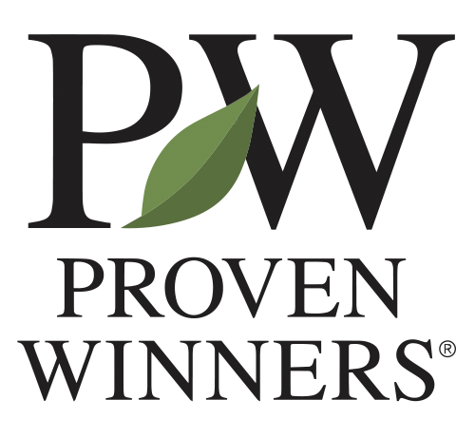
Product Development Assistant
Proven Winners, Inc.
Department | Product Development
Reports To | Product Development Supervisor; New Product Development Manager
Classification | Full Time, Year-Round, Non-Exempt
Location | Loudon, NH
Schedule / Travel | Monday-Friday 7:30am-4:00pm, occasional overtime. Weekend watering shifts are required on a rotating basis during spring and summer.
JOB SUMMARY
Execute day-to-day greenhouse and field activities associated with plant trialing at Proven Winners Loudon. Assist in establishing and maintaining healthy plant stock as well as ensuring accuracy for all plant labels. Become proficient with standard operating procedures for Product Development production, greenhouse and field tasks, and be willing to help other departments when necessary.
ESSENTIAL FUNCTIONS
- Perform plant production related tasks: plant identification, labeling, cutting, sticking, seeding, potting, plant maintenance, moving, shipping, dumping
- Sample collection for virus testing
- Follow sanitation and biosecurity procedures exactly as written, including between houses, trial blocks, and when moving between clean stock and trial material
- Garden bed preparation, planting, potting, weeding, and irrigation set-up and maintenance
- Photo documentation of trial material
- Update work reports and related paperwork during and upon completion of daily tasks
- Cleaning and maintenance of tools and work areas
- Communicate clearly with Product Development team members regarding task details and deadlines
REQUIRED KNOWLEDGE, SKILLS, AND ABILITIES
- Knowledge or experience in horticulture preferred
- Ability to perform multiple tasks in a fast-paced environment
- Excellent skills in organization and communication; detail-oriented
- Demonstrated ability to be punctual and prepared to work

EDUCATION AND EXPERIENCE REQUIREMENTS
- Highschool diploma or equivalent
- Previous horticultural background preferred
- Must obtain certification on heavy machinery, including forklifts and tractors, within 90 days of hire
PHYSICAL ASPECTS
- Bulk of job is spent standing or walking, sitting bending to the ground or reaching overhead.
- Ability to lift and carry up to 25 lbs., with or without reasonable accommodation.
- Employee will be exposed to sun and/or high intensity lights.
- Employee may be exposed to temperatures that can be 10-20 degrees about the outside temperature seasonally
- Employee may work in a wet environment where clothes and footwear can become saturated.
- Employee will work in areas where pesticides are applied and may be exposed to residue on plant material and surface
WORK ENVIRONMENT
Greenhouse/Field Work –
- Working in a building or outdoors with fluctuating temperatures and light exposure.
- Weather resistant clothes recommended
- Close-toed shoes are mandatory
- Pesticide applications occur in the greenhouses and fields. All restricted entry intervals must be observed and personal protective equipment worn as directed
CORE VALUES:
- Collaborating as One Team, One Proven Winners: Our future success is rooted in how well we work together—as one team, who is accountable to each other. Open, transparent, and direct communication remain central to our culture. We value the diverse strengths and perspectives each person brings and are committed to fostering a collaborative, inclusive, and respectful environment where everyone feels safe to challenge and learn from each other.
- Embracing Continuous Improvement: Proven Winners was built on the belief that we could always offer something better. This mindset continues to guide us—whether improving our products, our capabilities, or how we work together. Embracing change strengthens our future and helps us continue leading the industry.
- Pursuing Excellence: From superior plant genetics to building the most trusted brand in horticulture, excellence has always defined Proven Winners. We hold ourselves to high standards across product development, customer service, operations, and internal processes. By striving for excellence in everything we do, we continue to deliver exceptional value to our customers, partners, and one another.
- Doing the Right Thing: Our brand is all about trust. We make ethical, transparent, and well-intentioned decisions, even when the outcome is difficult. We honor our commitments and rely on one another to act with integrity. Together, we uphold this value by caring for one another and the communities that we serve.
- Prioritizing Safety: We prioritize the safety of our employees above all else. Our approach is proactive and prevention-focused, ensuring we maintain safe facilities, provide proper training, and empower every employee to prioritize safety in their daily work

NOTE
This job description does not exclude responsibilities not specifically stated, but that are apparent, related, or may develop in the normal course of duty.

